
Prof. Anushrav mudgal
Yash Kumar

JAVA LAB FILE

Q1. Write a Java program to demonstrate the use of different data types and control structures (if-else, switch, for loop, while loop).

Program:
public class Demo {
public static void main(String[] args) {
String name1 = "Vijay";
String name2 = "Yash";
String name3 = "Satish";

int a = 10;
char grade = 'B';

System.out.println(name1);
System.out.println(name2);
System.out.println(name3);

if (a > 0) {
System.out.println("Positive");
} else {
System.out.println("Negative");
}

switch (grade) {
case 'A':
System.out.println("Excellent");
break;
case 'B':
System.out.println("Good");
break;
default:
System.out.println("Average");
}

for (int i = 1; i <= 3; i++) {
System.out.println("For loop: " + i);
}

int x = 3;
while (x > 0) {
System.out.println("While loop: " + x);
x--;
}
}
}

Output:

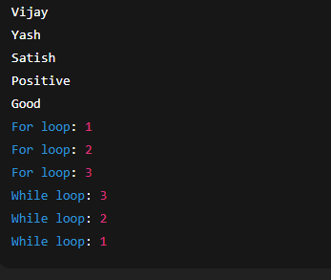

Q2. Write a Java program that calculates the factorial of a given number using both recursion and iteration.

Program:
public class FactorialDemo {

static int factorialRec(int n) {
if (n == 0)
return 1;
return n * factorialRec(n - 1);
}

static int factorialIter(int n) {
int result = 1;
for (int i = 1; i <= n; i++) {
result = result * i;
}
return result;
}

public static void main(String[] args) {
int num = 5;

int recResult = factorialRec(num);
int iterResult = factorialIter(num);

System.out.println("Recursive: " + recResult);
System.out.println("Iterative: " + iterResult);
}
}

Output:

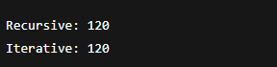

Q3. Write a Java program to find the second largest element in an array.

Program:
public class SecondLargest {
public static void main(String[] args) {
int[] arr = {10, 25, 7, 30, 18};

int first = Integer.MIN_VALUE;
int second = Integer.MIN_VALUE;

for (int n : arr) {
if (n > first) {
second = first;
first = n;
} else if (n > second && n != first) {
second = n;
}
}

System.out.println("Second Largest: " + second);
}
}

Output:

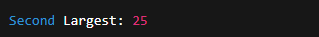

Q4. Write a Java program to check if a given string is a palindrome.

Program:
public class PalindromeCheck {
public static void main(String[] args) {
String str = "level";
String rev = "";

for (int i = str.length() - 1; i >= 0; i--) {
rev = rev + str.charAt(i);
}

if (str.equals(rev)) {
System.out.println("Palindrome");
} else {
System.out.println("Not Palindrome");
}
}
}

Output:

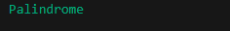

Q5. Write a Java program that demonstrates the use of interfaces, implementing multiple interfaces in a class.

Program:
interface A {
void showA();
}

interface B {
void showB();
}

class DemoClass implements A, B {
public void showA() {
System.out.println("Interface A method");
}

public void showB() {
System.out.println("Interface B method");
}
}

public class MultiInterfaceDemo {
public static void main(String[] args) {
DemoClass obj = new DemoClass();
obj.showA();
obj.showB();
}
}

Output:
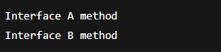

Q6. Write a Java program to create two threads: one thread prints even numbers and another thread prints odd numbers between 1 and 100.

Program:
class EvenThread extends Thread {
public void run() {
for (int i = 2; i <= 100; i += 2) {
System.out.println("Even: " + i);
}
}
}

class OddThread extends Thread {
public void run() {
for (int i = 1; i <= 100; i += 2) {
System.out.println("Odd: " + i);
}
}
}

public class ThreadDemo {
public static void main(String[] args) {
EvenThread e = new EvenThread();
OddThread o = new OddThread();
e.start();
o.start();
}
}

Output:

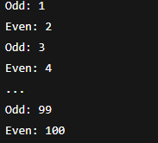

Q7. Write a Java program that inserts a new record into a MySQL database table and updates an existing record.

Program:
import java.sql.*;

public class DBInsertUpdate {
public static void main(String[] args) {
try {
Connection con = DriverManager.getConnection(
"jdbc:mysql://localhost:3306/testdb", "root", "");

Statement st = con.createStatement();

String insertQuery = "INSERT INTO students(id, name) VALUES(1, 'Vijay')";
st.executeUpdate(insertQuery);

String updateQuery = "UPDATE students SET name='Yash' WHERE id=1";
st.executeUpdate(updateQuery);

System.out.println("Record Inserted");
System.out.println("Record Updated");

con.close();
} catch (Exception e) {
System.out.println(e);
}
}
}

Output:

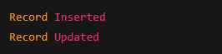

Q8. Write an applet that takes two numbers as input from the user and displays their sum.

Program:
import java.applet.*;
import java.awt.*;

public class SumApplet extends Applet {
TextField t1, t2, t3;
Button b;

public void init() {
t1 = new TextField(5);
t2 = new TextField(5);
t3 = new TextField(10);
b = new Button("Sum");

add(t1);
add(t2);
add(b);
add(t3);
}

public boolean action(Event e, Object o) {
int a = Integer.parseInt(t1.getText());
int b1 = Integer.parseInt(t2.getText());
int sum = a + b1;
t3.setText(String.valueOf(sum));
return true;
}
}
HTML to run the Applet :
<html>
<body>
<applet code="SumApplet.class" width="300" height="200"></applet>
</body>
</html>
Output:

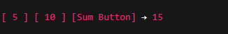

Q9. Create a simple Java GUI using AWT with a Button that changes the background color when clicked.

Program:
import java.awt.*;
import java.awt.event.*;

public class ColorChangeAWT extends Frame implements ActionListener {
Button b;

public ColorChangeAWT() {
b = new Button("Change Color");
add(b);
b.addActionListener(this);
setSize(300, 200);
setLayout(new FlowLayout());
setVisible(true);
}

public void actionPerformed(ActionEvent e) {
setBackground(Color.yellow);
}

public static void main(String[] args) {
new ColorChangeAWT();
}
}

Output:
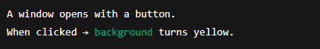

Q10. Write a Java program that demonstrates the use of BorderLayout and FlowLayout.

Program:
import java.awt.*;

public class LayoutDemo extends Frame {
public LayoutDemo() {
setSize(400, 300);
setVisible(true);

setLayout(new BorderLayout());
add(new Button("North"), BorderLayout.NORTH);
add(new Button("South"), BorderLayout.SOUTH);
add(new Button("East"), BorderLayout.EAST);
add(new Button("West"), BorderLayout.WEST);

Panel p = new Panel();
p.setLayout(new FlowLayout());
p.add(new Button("A"));
p.add(new Button("B"));
p.add(new Button("C"));

add(p, BorderLayout.CENTER);
}

public static void main(String[] args) {
new LayoutDemo();
}
}

Output:
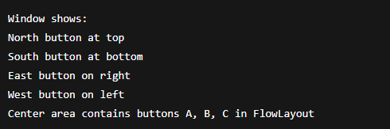

Q11. Write a program to count the number of objects created in a program.

Program:
public class ObjectCount {
static int count = 0;

public ObjectCount() {
count++;
}

public static void main(String[] args) {
ObjectCount o1 = new ObjectCount();
ObjectCount o2 = new ObjectCount();
ObjectCount o3 = new ObjectCount();

System.out.println("Objects created: " + count);
}
}

Output:
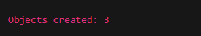

Q12. Write a Java program that implements a client-server application using UDP (DatagramSocket) for sending and receiving messages.

Server Program (UDPServer.java)

import java.net.*;

public class UDPServer {
public static void main(String[] args) {
try {
DatagramSocket ds = new DatagramSocket(5000);
byte[] buffer = new byte[1024];

DatagramPacket dp = new DatagramPacket(buffer, buffer.length);
ds.receive(dp);

String msg = new String(dp.getData(), 0, dp.getLength());
System.out.println("Received: " + msg);

ds.close();
} catch (Exception e) {
System.out.println(e);
}
}
}

Client Program (UDPClient.java)

import java.net.*;

public class UDPClient {
public static void main(String[] args) {
try {
DatagramSocket ds = new DatagramSocket();

String msg = "Hello Server";
byte[] data = msg.getBytes();

InetAddress ip = InetAddress.getByName("localhost");
DatagramPacket dp = new DatagramPacket(data, data.length, ip, 5000);

ds.send(dp);
System.out.println("Message Sent");

ds.close();
} catch (Exception e) {
System.out.println(e);
}
}
}

Output:
Client side:
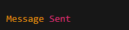
Server side:
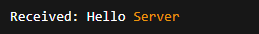

Q13. Write a Java GUI application that changes text on a label when a button is clicked, demonstrating event handling.

Program:
import java.awt.*;
import java.awt.event.*;

public class LabelChange extends Frame implements ActionListener {
Label l;
Button b;

public LabelChange() {
l = new Label("Old Text");
b = new Button("Change Text");

add(l);
add(b);

b.addActionListener(this);

setLayout(new FlowLayout());
setSize(300, 200);
setVisible(true);
}

public void actionPerformed(ActionEvent e) {
l.setText("New Text");
}

public static void main(String[] args) {
new LabelChange();
}
}

Output:
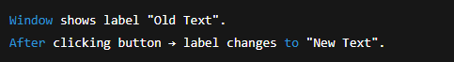

Q14. Write a Java program to establish a connection with a MySQL database and retrieve data from a table.

Program:
import java.sql.*;

public class DBSelect {
public static void main(String[] args) {
try {
Connection con = DriverManager.getConnection(
"jdbc:mysql://localhost:3306/testdb", "root", "");

Statement st = con.createStatement();
ResultSet rs = st.executeQuery("SELECT * FROM students");

while (rs.next()) {
System.out.println(rs.getInt(1) + " " + rs.getString(2));
}

con.close();
} catch (Exception e) {
System.out.println(e);
}
}
}

Output:

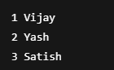

Q15. Create a custom tag in JSP that takes user input (name, age) and displays it dynamically in different sections of the web page.
Step 1: Create the custom tag file
<%@ tag language="java" %>
Name: ${param.name} <br>
Age: ${param.age} <br><br>

Step 2: JSP page using the custom tag
<%@ taglib prefix="t" tagdir="/WEB-INF/tags" %>

<html>
<body>

<form action="user.jsp" method="post">
Name: <input type="text" name="name"><br>
Age: <input type="text" name="age"><br>
<input type="submit" value="Submit">
</form>

<t:showUser />

</body>
</html>

Output:

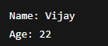

Q16. Write a servlet that retrieves user input (name and age) from an HTML form and displays the information on another web page.

HTML Form (input.html)
<html>
<body>
<form action="DisplayServlet" method="post">
Name: <input type="text" name="name"><br>
Age: <input type="text" name="age"><br>
<input type="submit" value="Submit">
</form>
</body>
</html>

Servlet (DisplayServlet.java)
import java.io.*;
import jakarta.servlet.*;
import jakarta.servlet.http.*;

public class DisplayServlet extends HttpServlet {
public void doPost(HttpServletRequest req, HttpServletResponse res)
throws IOException, ServletException {

res.setContentType("text/html");
PrintWriter out = res.getWriter();

String name = req.getParameter("name");
String age = req.getParameter("age");

out.println("Name: " + name + "<br>");
out.println("Age: " + age);
}
}
Output:
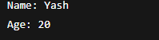

Q17. Create a web page that displays a table with different formatting options (rowspan, colspan, borders).
HTML Code:
<html>
<body>
<table border="2" cellpadding="10">
<tr>
<th colspan="2">Student Info</th>
</tr>

<tr>
<td rowspan="2">Vijay</td>
<td>Age: 21</td>
</tr>

<tr>
<td>City: Mumbai</td>
</tr>

<tr>
<td>Yash</td>
<td>Age: 22</td>
</tr>

<tr>
<td>Satish</td>
<td>Age: 20</td>
</tr>
</table>
</body>
</html>
Output:
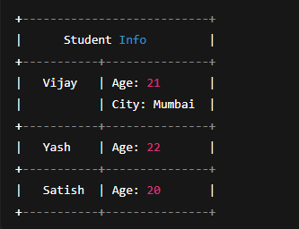

Q18. Create an image map in HTML, where clicking on different regions of an image navigates to different web pages.

HTML Code:
<html>
<body>

<img src="worldmap.jpg" usemap="#map1" width="500" height="300">

<map name="map1">

<area shape="rect" coords="50,50,150,150" href="india.html">
<area shape="circle" coords="300,150,40" href="usa.html">
<area shape="rect" coords="350,50,450,150" href="china.html">

</map>

</body>
</html>

Output:

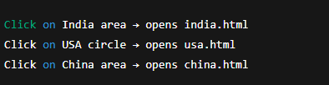

Q19. Write a servlet that tracks user sessions using cookies and displays the number of times a user has visited the website.

Program (VisitCounter.java):
import java.io.*;
import jakarta.servlet.*;
import jakarta.servlet.http.*;

public class VisitCounter extends HttpServlet {
public void doGet(HttpServletRequest req, HttpServletResponse res)
throws IOException, ServletException {

res.setContentType("text/html");
PrintWriter out = res.getWriter();

int count = 0;

Cookie[] cookies = req.getCookies();
if (cookies != null) {
for (Cookie c : cookies) {
if (c.getName().equals("visits")) {
count = Integer.parseInt(c.getValue());
}
}
}

count++;

Cookie ck = new Cookie("visits", String.valueOf(count));
res.addCookie(ck);

out.println("Number of visits: " + count);
}
}

Output :
First visit:
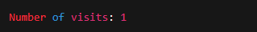

Second visit:
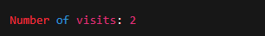
Third visit:

(Continues increasing.)

Q20. Write a JSP page that takes input from the user (name, age) and generates a personalized greeting message.

JSP Code (greet.jsp):
<html>
<body>

<form method="post">
Name: <input type="text" name="name"><br>
Age: <input type="text" name="age"><br>
<input type="submit" value="Submit">
</form>

<%
String name = request.getParameter("name");
String age = request.getParameter("age");

if (name != null && age != null) {
out.println("Hello " + name + ", you are " + age + " years old.");
}
%>

</body>
</html>

Output:
If user enters:
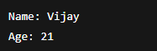
Then output:
